***1)A stove element draws 10 A when connected to a 240-V line. How long does it take to consume 120 kJ? (explain)***

**Answer 1 :**

**Amper= 10A**

**Voltage = 240 V**

**Energy = 120 kj**

**t=?**

P= V x I

P = 240 X 10 = 2400

E = P x t

120 X 1000 = 2400 x t

120.000 = 2400 x t

T = 50 second

**2)Calculate the power supplied or absorbed by each element.**

**Answer 2:**

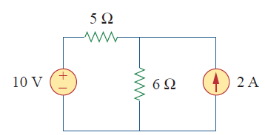



KCL => İO  + 2A = İX

KCL => 10V – İ0.5 – 6.İX =0

=10V – 5İ0 – 6[2 + İO] = 0

=10V – 5İ0 – 12 - 6İ0 = 0

11İ0 = -2

İ0 = -2/11

P=I.V

VAK= VX- VY = 6x (20/11) = 120/11

PP = VAK.İA = 2. (120/11) = 240/11 = 21.818 W

P10V = (-2/11).10 = -20/11 = -1.81

PProduction- PConsumption = 0

That's why it's negative.

P10Ω= İ2.R = ((-2/11).A)2.5 = -20/121 = -0.16

P50 Ω= İ2.R= ((20/11)2.6)= -2400/121 = -19.8

-1.81 -0.16-19.8 = -21.818

PP=PC